

Data Prep & Ethics

Data Analytics Capstone
Course Code: MGMT 6219

Name | Student ID
Absasiaka Anwanakak | 1208151
Gift Oyugi | 1349890
Damian Okelue | 1298980
Sahil Kamane | 1273968
Busayo Adebayo | 1233210

Institution: Fanshawe College
Date: July 15th, 2026
Table of Contents
Revised Business Challenge 3
Data Management Artifacts 3
Final Cleaned Dataset 3
Data Dictionary 4
Data Lineage Documentation 5
Data Quality Assessment 6
Checks Performed 7
Detailed Data-Quality Findings 8
Outlier Assessment 8
Remaining Limitations and Analytical Impact 9
Data-Quality Controls for Future Versions 9
Exploratory Data Analysis 10
Descriptive Statistics & Distributions 11
Distribution of Average Order Value (AOV) 11
Key Visualizations 12
Preliminary Findings 15
Hypotheses for Further Analysis 16
Patterns, Anomalies & Outliers: 16
Ethics & Governance Assessment 17
Introduction 17
Data Privacy and Confidentiality 17
Data Governance and Integrity 18
Fairness, Bias, and Responsible Interpretation 18
Compliance and Responsible Use of Findings 19
Conclusion 19
References 20

Revised Business Challenge
The main business objective of the organization is to know which provinces have the average order value (AOV) above the $120 target and analyze the performance of each province. Also, the project will examine provincial differences in the average order value and order count, leveraging the available customer-level data to pinpoint top-performing markets and areas in need of enhancement. The analysis will provide data-driven recommendations for Canada Vapes to focus on the provinces that have the most potential to increase customer value and aid in the achievement of its AOV growth objective.

Data Management Artifacts

Final Cleaned Dataset
CanadaVapesDataset_Final.csv is the only dataset intended for analysis. It contains the seven business fields from the supplied export plus two derived quality flags. No raw or partially cleaned files are included in the analytical handoff. (Canada Vapes, 2026).
Data element | Final treatment
Dates | Parsed and exported as YYYY-MM-DD HH:MM:SS; missing Sign Up values remain blank and are flagged
Numerics | Orders stored as positive integers; Total Spend and AOV stored to two-decimal precision
AOV | Recalculated as Total Spend ÷ Orders to remove rounding inconsistencies
Geography | City trimmed and normalized; Region standardized to uppercase two-letter codes
Duplicates | Exact duplicate rows checked after standardization; none remained
Conflicts | Sign Up after Last Active retained and marked with Date Sequence Flag for source-owner review

Data Dictionary
Field Name | Description | Data Type | Units | Data Source | Cleaning Decision
Last Active | Timestamp of the latest recorded  customer interaction | Datetime stored as ISO-8601 text | N/A | Provided Canada Vapes export file | Parsed and standardized; required
Sign Up | Timestamp of account creation | Datetime stored as ISO-8601 text | N/A | Provided Canada Vapes export file | Nulls retained; missing-value flag added
Orders | Successful orders attributed  to the customer-level record | Integer | Order count | Provided Canada Vapes export file | Required; values must be positive integers
Total Spend | Cumulative value of observed orders | Decimal/float | CAD | Provided Canada Vapes export file | Required; rounded to two decimals
AOV | Customer-level average order value:  Total Spend divided by Orders | Decimal/float | CAD per order | Derived from Total Spend and Orders | Recalculated and rounded to two decimals
City | Customer shipping municipality | String | N/A | Provided Canada Vapes export file | Trimmed, internal spaces  normalized, title case applied
Region | Canadian province or territory abbreviation | String | Two-letter code | Provided Canada Vapes export file | Trimmed and converted to uppercase
Sign Up Missing Flag | Indicates that Sign Up is unavailable | Boolean | True/False | Derived quality flag | True for retained missing Sign Up values
Date Sequence Flag | Indicates that Sign Up occurs after Last Active | Boolean | True/False | Derived quality flag | True records require source-owner review

Data Lineage Documentation
The project uses a single supplied customer-level export; no joins were performed. The specific upstream platform, extraction query, cadence, source timezone, and raw file were not supplied. The lineage below therefore distinguishes the documented processing design from upstream facts that require confirmation by the data owner.
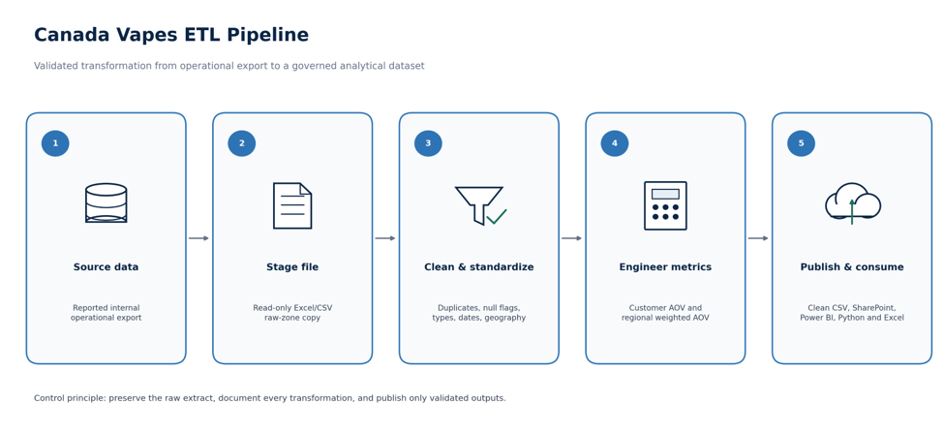
Figure 1. ETL flow from the reported operational export to the governed analytical output.

Stage | Artifact or process | Control
Extract | Reported internal operational export | Preserve raw copy; record source, extraction time, timezone, row count, and checksum
Stage | Excel/CSV working copy | Prevent manual edits to raw artifact; reconcile staged and raw row counts
Transform | Python/Pandas | Parse types, normalize geography, check duplicates, retain and flag unresolved exceptions
Engineer | Derived fields and aggregate metrics | Customer AOV = spend/orders; corporate AOV = total spend/total orders
Load | Final CSV and governed repository | Version output, restrict access, record pipeline version, and publish validation results
Consume | Power BI, Python, and Excel | Connect to the governed path; avoid uncontrolled local copies

Lineage status: Downstream calculations are reproducible from the supplied file. End-to-end provenance remains partially evidenced until the raw extract, source manifest, and ETL execution log are provided.

Data Quality Assessment
Fitness verdict: Fit with qualifications for province-level revenue, orders, and AOV analysis. Not yet fit for verified unique customer counts, transaction-level time series, or unreviewed automated marketing decisions.
Dimension | Assessment | Evidence | Severity
Completeness | Pass with exception | Required analytical fields are 100% complete; Sign Up is missing for 44 records (0.14%) | Low
Uniqueness | Qualified | No exact duplicate rows; customer uniqueness cannot be proven without a key | Medium
Accuracy | Pass | AOV reconciles to Total Spend ÷ Orders within $0.01 in every source row | Low
Consistency | Needs remediation | 74 date-sequence exceptions and 394 City values with outer whitespace | Medium
Validity | Pass | Orders are positive integers; spend/AOV are non-negative; all 13 region codes are valid | Low
Timeliness | Not fully assessable | Latest activity is July 8, 2026; extraction timestamp and refresh SLA are absent | Medium
Metric integrity | Resolved in report | Corporate weighted AOV separated from mean customer AOV | High if mixed
Table 2. Data-quality assessment by dimension. Severity reflects the impact on the requested analysis.

Checks Performed
- Completeness. Null and blank rates were calculated for every field and required-field coverage was verified.
- Uniqueness. Exact duplicates were tested before and after standardization; candidate customer uniqueness could not be tested without a key.
- Accuracy and validity. Numeric ranges, integer conformance, timestamp parsing, accepted region values, and AOV formula reconciliation were tested.
- Consistency. Date sequence, City whitespace/case, region format, and cross-field AOV agreement were reviewed.
- Distribution of shapes. IQR and percentile screening were used to identify high-value observations without automatically deleting valid records.

Detailed Data-Quality Findings
Issue | Evidence | Treatment | Residual impact
Missing Sign Up | 44 records (0.1439%) | Retained because orders, spend, AOV and geography remain complete; added Sign Up Missing Flag | Guest-checkout explanation remains unverified
Exact duplicates | 0 rows | No removal required in final file | No customer key to detect repeated people/accounts
AOV calculation | Maximum source difference $0.005 | Recalculated and rounded to two decimals | None for row-level arithmetic
Date sequence | 74 records (0.24%) | Retained and flagged | May affect signup cohort or tenure analysis
City format | 394 rows (1.29%) with outer whitespace | Trimmed, spaces normalized and title case applied | Municipality aliases may still require reference mapping
Region codes | 0 invalid values | Standardized to uppercase | Code set should be governed in future refreshes

Outlier Assessment
Metric | IQR upper bound | Rows flagged | Share | Observed maximum
Orders | 11.00 | 3,715 | 12.15% | 240.00
Total Spend | 1,072.56 | 4,403 | 14.40% | 30,986.47
AOV | 201.10 | 1,742 | 5.70% | 1,613.57

The upper tail was retained. Values are internally consistent and may reflect highly engaged, enterprise, or wholesale accounts. Removing them would understate revenue and distort provincial weighted AOV. Behavioral conclusions should therefore include medians, percentiles, or sensitivity analyses, and future data should include an explicit customer-type flag.

Remaining Limitations and Analytical Impact
Limitation | Potential impact | Required next step
No customer identifier | Cannot verify unique customers or account duplication | Use customer-level records terminology; add a privacy-safe key
No transaction dates | Cannot establish monthly trends, seasonality, or annualized opportunity | Obtain order-level dated transactions
No product fields | Cannot assess product-category or flavor preferences | Add governed product category and regulatory classification
No shipping/tax fields | Logistics explanations remain hypotheses | Add shipping charge, distance, tax, and fulfillment data
Lifetime totals | Revenue-lift scenarios are historical equivalents, not forecasts | Define a reporting window before forecasting

Data-Quality Controls for Future Versions
Control family | Automated test | Response
Schema | Expected fields and data types | Fail refresh if required fields are missing or retyped
Completeness | Required fields non-null; Sign Up null rate monitored | Alert on unexpected null-rate increase
Domains | Orders > 0; spend/AOV ≥ 0; accepted region codes | Quarantine invalid rows
Formula | |AOV − Total Spend/Orders| ≤ $0.01 | Recalculate or reject inconsistent records
Identity | Stable customer key unique at intended grain | Resolve duplicates before aggregation
Freshness | Extract timestamp and refresh SLA | Alert when dataset is stale
Distribution | Median, p95/p99, region mix and high-value share | Investigate sudden shifts rather than deleting automatically
Table 3. Proposed automated controls for a repeatable production-quality pipeline.
Data-management conclusion: The final dataset is clean and well documented for the stated provincial AOV analysis. The most important governance improvement is adding a stable customer key and extract metadata while preserving explicit quality flags

Exploratory Data Analysis
Exploratory Data Analysis (EDA) was conducted on the cleaned Canada Vapes dataset to better understand customer purchasing behaviour before moving into more detailed analysis. The exploration focused on key variables including Orders, Total Spend, Average Order Value (AOV), Sign Up date, Last Active date, and Province to examine their distributions, identify outliers, and explore how customer spending and purchasing patterns differ across Canadian provinces. This initial exploration made it easier to understand the dataset and guided the selection of visualizations and analyses presented for the business questions this report.

Descriptive Statistics & Distributions
Statistic | Orders | Total Spend ($) | AOV ($)
Count | 30,578 | 30,578 | 30,578
Mean | 5.40 | 677.50 | 100.50
Median | 2.00 | 154.35 | 84.73
Std. Dev. | 10.04 | 1593.81 | 62.08
Minimum | 1 | 1.30 | 1.30
Maximum | 240 | 30,986 | 1,614
Table 1. Descriptive Statistics of Key Variables
Summary statistics were calculated for the three main numerical variables in the dataset: Orders, Total Spend, and Average Order Value (AOV). The table includes the count, mean, median, standard deviation, minimum, and maximum for each variable to provide an overall view of customer purchasing behaviour. One noticeable finding is that the mean AOV ($100.50) is higher than the median ($84.73), suggesting that a smaller number of higher-value purchases increased the overall average. This was explored further in the distribution analysis.

Distribution of Average Order Value (AOV)
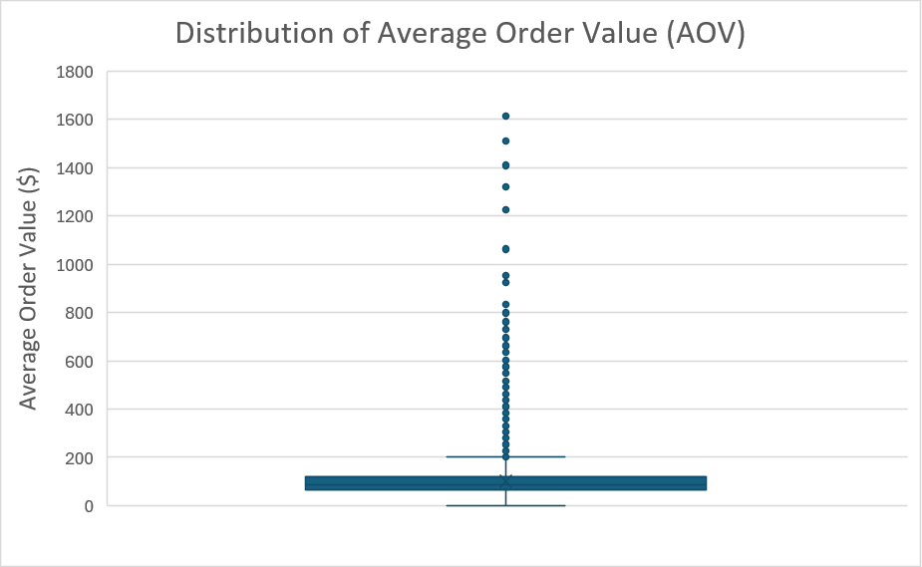
Figure 1. Box plot showing the distribution of Average Order Value (AOV).

The box plot shows that the middle 50% of customer orders are concentrated within a narrow range around the median value of $84.73. Several high-value orders extend to approximately $1,614, creating a right-skewed distribution and increasing the mean AOV to $100.50. These observations were reviewed and retained because they represent valid customer transactions rather than data entry errors.

Key Visualizations
The following visualizations explore key patterns in the Canada Vapes dataset using variables such as Average Order Value (AOV), Total Spend, Orders, and Customer Tenure. Each figure highlights a different aspect of customer purchasing behaviour and provides evidence to support the business questions identified in this analysis.

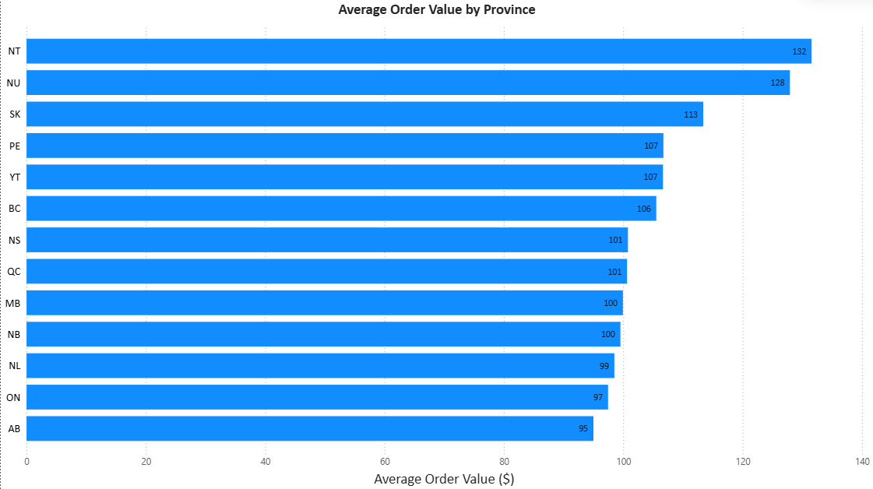Figure 2. Average Order Value by Province.
This chart compares the average order value (AOV) by province and territory in Canada to see which provinces or territories have higher average transaction value. The highest average order value was in the NWT at $132, then NU at $128 and SK at $113. Alberta (AB), on the other hand, showed the lowest average order value at $95, while Ontario (ON) posted an average of $97. In general, there are differences in province-wise customer spending suggesting that customers in some regions consistently place higher-value orders than others.

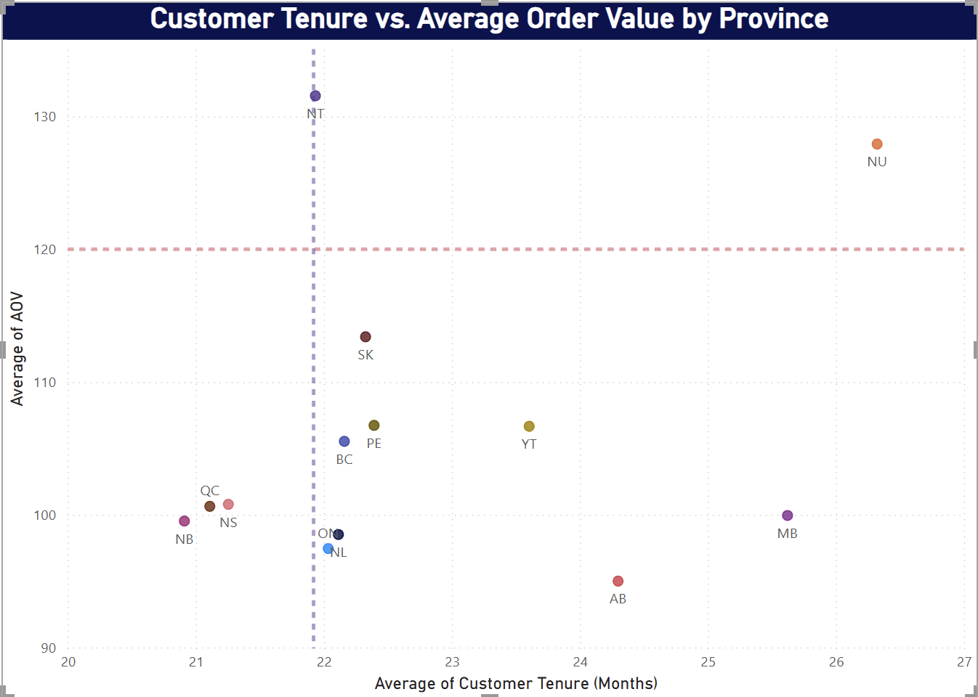Figure 3: Customer Tenure vs. Average Order Value by Province

This scatter plot compares the average customer tenure against average order value of above $120, by province in Canada. The vertical and horizontal lines indicate the overall averages for both measures and help to identify provinces that are higher or lower than the average of the dataset. The NWT and Nunavut (NU) are the only two above the $120 average order value, and Nunavut (NU) is the top province for customer tenure. On the other hand, provinces such as Alberta (AB) and Ontario (ON) fall below the overall average for order value despite having longer customer tenures. Overall, the chart shows that longer customer relationships do not always translate into higher spending, indicating that additional factors may influence customer value across provinces.

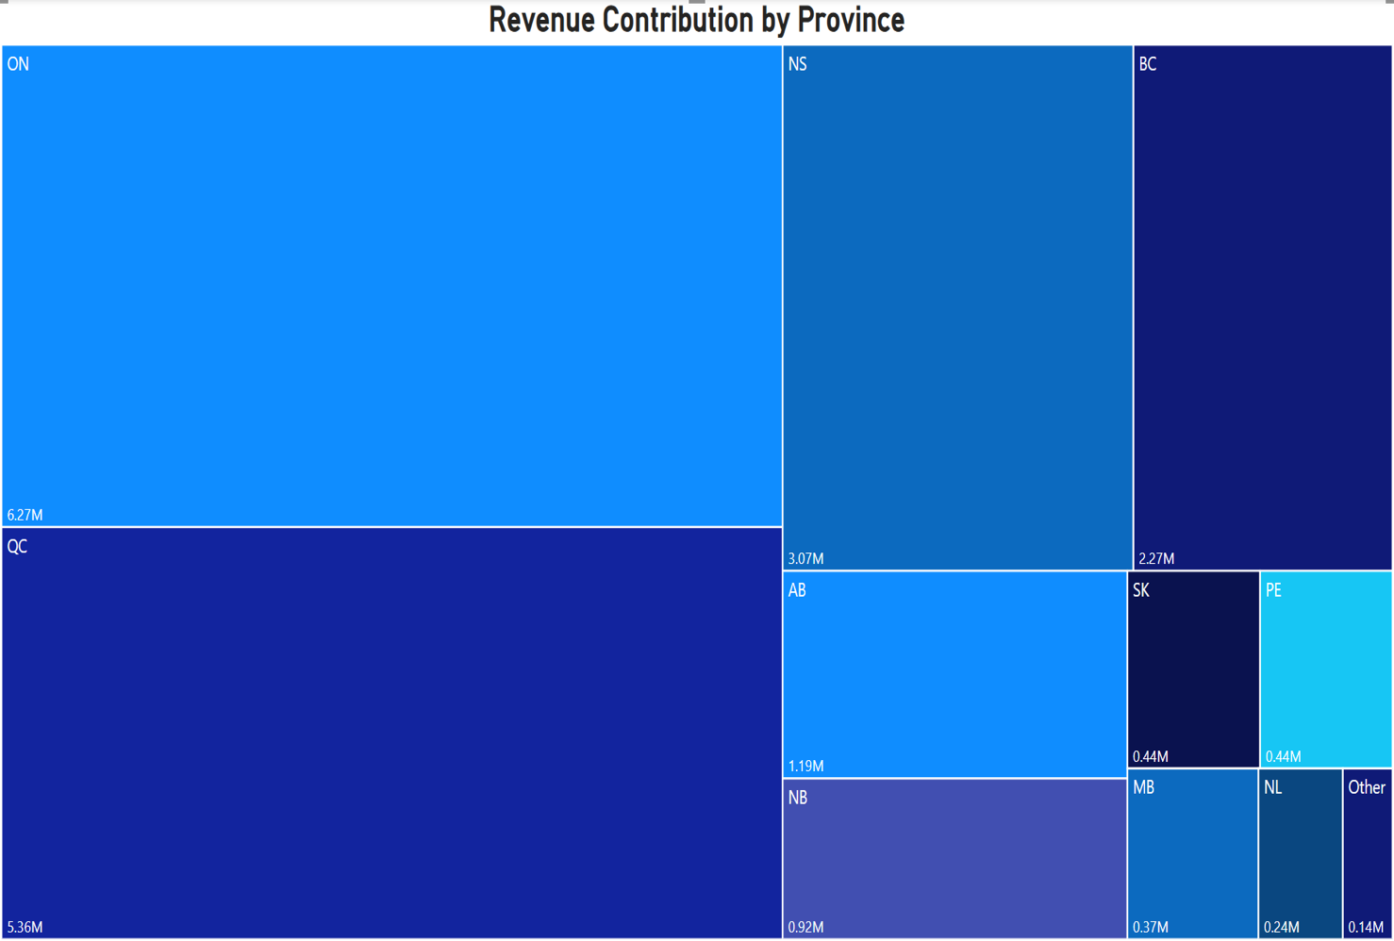Figure 4. Revenue Contribution by Province.
This tree map shows how total revenue is distributed across the Canadian provinces. Ontario (ON) and Quebec (QC) contribute the largest share of total revenue, followed by Nova Scotia (NS) and British Columbia (BC). In contrast, other provinces such as Nunavut (NU), Northwest Territories (NT), and Yukon (YT) contribute relatively little revenue. These results suggest that while some provinces generate higher-value transactions (Figures 2 and 3), Ontario and Quebec remain the largest revenue contributors because of their overall sales volume.

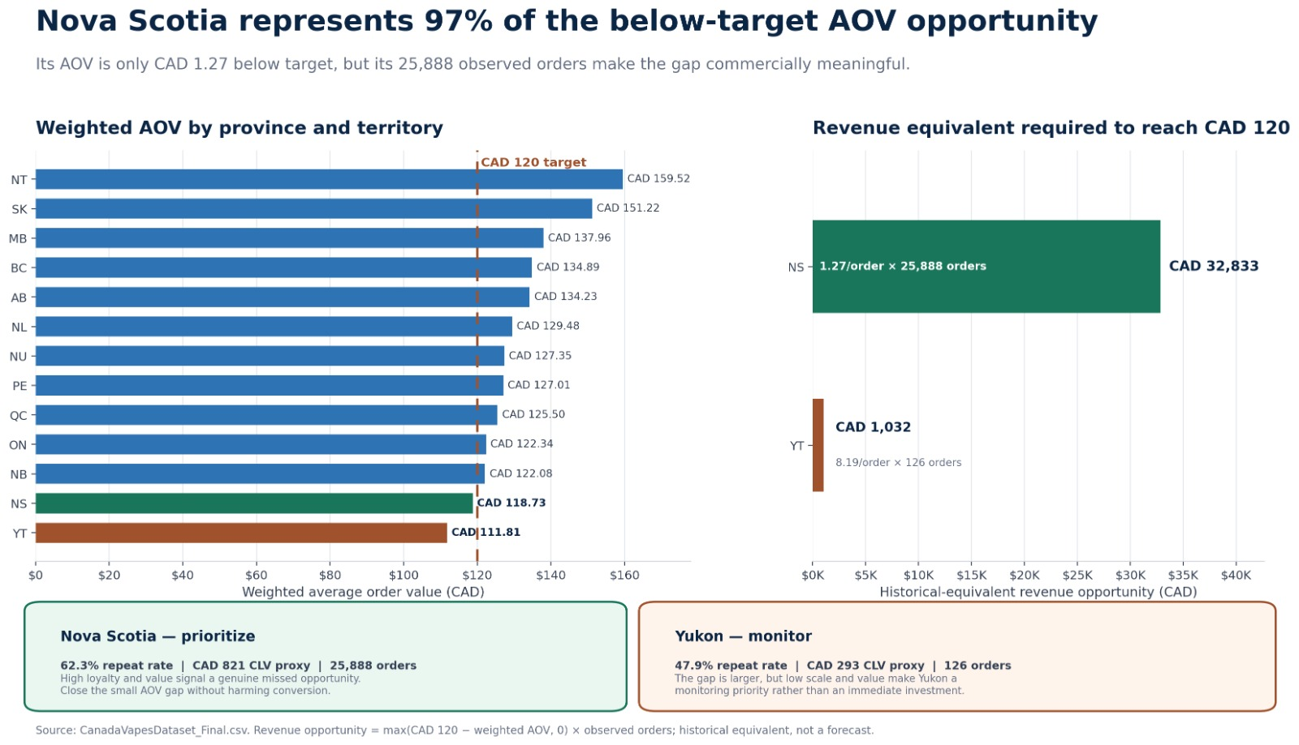
Figure5: Revenue Opportunity to Achieve the $120 AOV Target

Nova Scotia represents the largest opportunity to increase average order value, contributing 97% of the below-target AOV gap because of its high order volume despite being only $1.27 below the business target. In comparison, Yukon has a larger per-order gap but a much smaller overall revenue opportunity due to its low sales volume.

Preliminary Findings
- Average Order Value (AOV) is positively skewed. A small number of high-value purchases increase the mean AOV ($100.50) above the median ($84.73).
- Customer spending differs across provinces. NT and NU recorded the highest average order values, while AB and ON recorded the lowest.
- Higher average order values do not always result in higher total revenue. Ontario generates the largest share of revenue despite having a lower-than-average AOV.
- Customer tenure does not appear to have a strong relationship with average order value. Provinces with longer average tenures do not consistently record higher spending.

Hypotheses for Further Analysis
- Customers with longer tenures may have higher average order values. This relationship will be tested using correlation or regression analysis.
- Provinces currently below the business target of $120 AOV may require different marketing or pricing strategies than provinces already exceeding the target.
- Provinces with higher total revenue are expected to have higher purchase frequency or larger customer volumes, rather than consistently higher order values.
- The differences in average order value observed across provinces may be influenced by regional purchasing behaviour.
- High-value purchases identified as outliers may represent a distinct customer segment. Understanding the characteristics of these customers may help identify opportunities to increase average order value.

Patterns, Anomalies & Outliers:
Pattern / Anomaly | Data Error or Genuine Phenomenon
High-value AOV transactions (maximum AOV ≈ $1,614) | Genuine phenomenon. The records showed no signs of duplication or data entry errors and reflected actual customer purchases.
Missing City or Region values (68 records) | Data quality issue. Missing location information prevented reliable provincial analysis.
Zero-value AOV or Total Spend (157 records) | Data quality issue. These records did not represent meaningful customer purchases and could bias the analysis.
Provinces with the highest AOV were not the highest revenue contributors | Genuine phenomenon. Revenue and AOV measured different aspects of customer purchasing behaviour.
Customer tenure did not consistently align with higher AOV | Genuine phenomenon. No clear relationship was observed during the exploratory analysis.

Missing values:
Records with missing City or Region values were removed because they could not be assigned to a province. Since this report compares customer behaviour across provinces, these records would not have contributed meaningful insights.
Zero-value transactions:
Records with an AOV or Total Spend of $0 were also removed because they did not represent actual customer purchases. Keeping them would have lowered the averages and affected the overall results.
Outliers:
The unusually high AOV values were reviewed before deciding whether to remove them. Although they stood out from the rest of the data, there was no indication that they were data entry errors or duplicate records. They were therefore kept because they reflect real customer purchases and provide a more accurate picture of customer spending.
Data transformations:
The Sign Up and Last Active fields were converted to a consistent Date/Time format, while Orders, Total Spend, and AOV were stored as numeric values. These changes ensured that calculations, summary statistics, and visualizations were generated correctly.

Ethics & Governance Assessment

Introduction
Responsible data management is essential to ensuring that analytical findings are accurate, trustworthy, and ethically sound. This project uses customer-level transactional data provided by Canada Vapes to evaluate purchasing behaviour and identify provincial growth opportunities. Although the dataset does not contain direct personal identifiers such as customer names or contact information, it includes commercially sensitive information related to customer purchasing activity. Therefore, the project follows responsible data governance practices to protect confidentiality, maintain data integrity, and ensure that analytical findings are used appropriately to support business decision-making.

Data Privacy and Confidentiality
The dataset used for this project contains customer transaction information, including purchase history, order values, activity dates, and geographic location by city and province. While direct personal identifiers are not included, the information remains confidential because it represents proprietary business data.
To protect confidentiality, the dataset will be used exclusively for the Riipen capstone project and accessed only by authorized team members and course instructors. Project files will be stored within secure collaboration platforms approved by the team, and no confidential business information will be shared outside the project. Results presented in the report and presentation will be aggregated at the provincial level, ensuring that individual customer records cannot be identified.

Data Governance and Integrity
Maintaining data integrity was a key consideration throughout the data preparation process. All cleaning decisions were documented to ensure transparency and reproducibility. Records with missing province information were removed because they could not contribute to the project's province-level analysis, while inconsistent transactional records with orders recorded but zero spending were excluded to prevent misleading analytical results. Legitimate high-value transactions were retained after review because they reflected plausible customer behaviour rather than data entry errors.
The project also follows good governance practices by preserving the original dataset, documenting data transformations, and maintaining version control for analytical files. These practices improve the reliability of the analysis and allow project findings to be reproduced if additional data becomes available.
Fairness, Bias, and Responsible Interpretation
The project recognizes that historical transactional data may not fully represent future market potential. Provinces with higher revenue or larger customer bases may reflect existing market size, customer distribution, or previous business strategies rather than inherently greater growth opportunities. Similarly, provinces with higher Average Order Values may have relatively small customer populations, making comparisons sensitive to sample size.
To reduce bias, recommendations will not rely solely on one performance measure. Instead, internal sales data will be interpreted alongside external information on provincial regulations, taxation, competition, and market maturity. This balanced approach helps ensure that recommendations are supported by multiple sources of evidence and avoids overgeneralizing results from historical data.
The team also recognizes that the dataset does not include demographic information, product categories, marketing campaign data, or customer identifiers. These limitations will be acknowledged when interpreting findings, and conclusions will be restricted to the available evidence rather than unsupported assumptions.

Compliance and Responsible Use of Findings
The project team is committed to handling Canada Vapes' data responsibly and using it solely for academic analysis within the Riipen project. All recommendations will be developed in accordance with applicable privacy principles and with consideration of Canada's regulatory environment for vaping products.
The purpose of this analysis is to identify business opportunities rather than encourage inappropriate marketing practices. Any recommendations will focus on enhancing customer value and supporting strategic decision-making, while ensuring that marketing activities comply with provincial regulations and do not target underage individuals or encourage irresponsible product use.

Conclusion
Ethical data governance is fundamental to producing credible and responsible business insights. By protecting confidential information, documenting data management decisions, acknowledging potential sources of bias, and interpreting results responsibly, the project aims to provide Canada Vapes with transparent and evidence-based recommendations. These practices enhance the reliability of the analysis, support responsible decision-making, and maintain the project's integrity.

References
Canada Vapes. (2026). CanadaVapesDataset_Final [Unpublished internal data set].
International Organization for Standardization. (2008). Software engineering—Software product quality requirements and evaluation (SQuaRE)—Data quality model (ISO/IEC Standard No. 25012:2008). https://www.iso.org/standard/35736.html
The pandas development team. (n.d.). pandas documentation. Retrieved July 15, 2026, from https://pandas.pydata.org/docs/
Note. CanadaVapesDataset_Final is an internal project file and is not publicly retrievable.

